Building Mental Health
This is to certify that

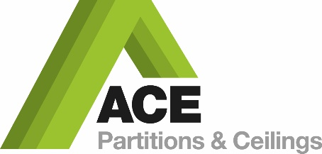

will adopt and commit to the principles of the
Building Mental Health Charter

Principles

Our company is signing this charter and pledging to:

    - Provide awareness and understanding of the impact of poor mental ill health to our workforce and promote positive mental health through facilitated workshops, with the aims of:
        - Reducing stigma and discrimination
        - Encouraging conversation in the workplace

    - Educate and enable champions from across the workforce to support keeping our people safe

    - Provide access to accredited Mental Health First Aid training and provide assistance to signpost workers to support in their communities

    - Recognise and accept education and training provided by peers and Building Mental Health partners

As a company, we are committing to the Building Mental Health Framework which underpins the values of our business and supports people in our industry, every day, and throughout their working lives.

Leanne Pearson- Accountant
Ace Partitions & Ceilings Ltd
Sign up Year
2021

